Module 03 Course Project

Tracy Brevig

Rasmussen College

COURSE#: W110/COP1801 Section 01 Javascript

Instructor’s Name: Kimberly Powell

February 15, 2021

**Loaded Pages:**

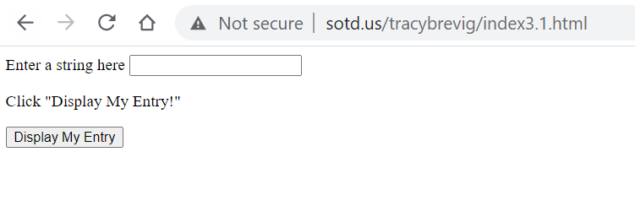

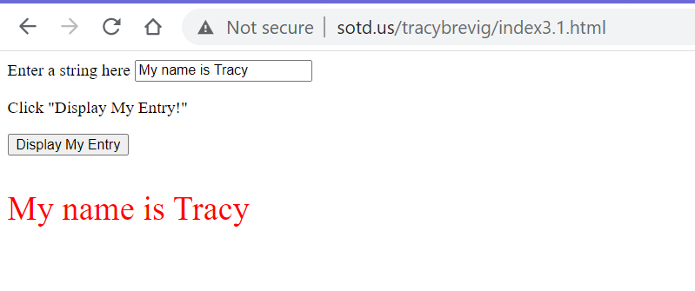

**URL Link:**

<http://sotd.us/tracybrevig/index3.1.html>